#### FAQ: Frequently Asked Questions on Co-WIN

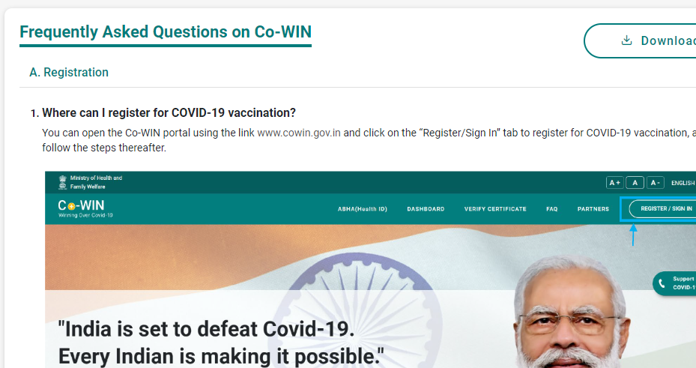

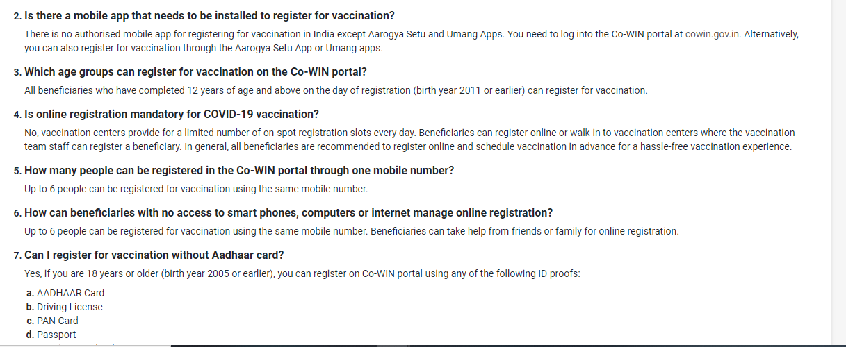

**PARTNERS**:

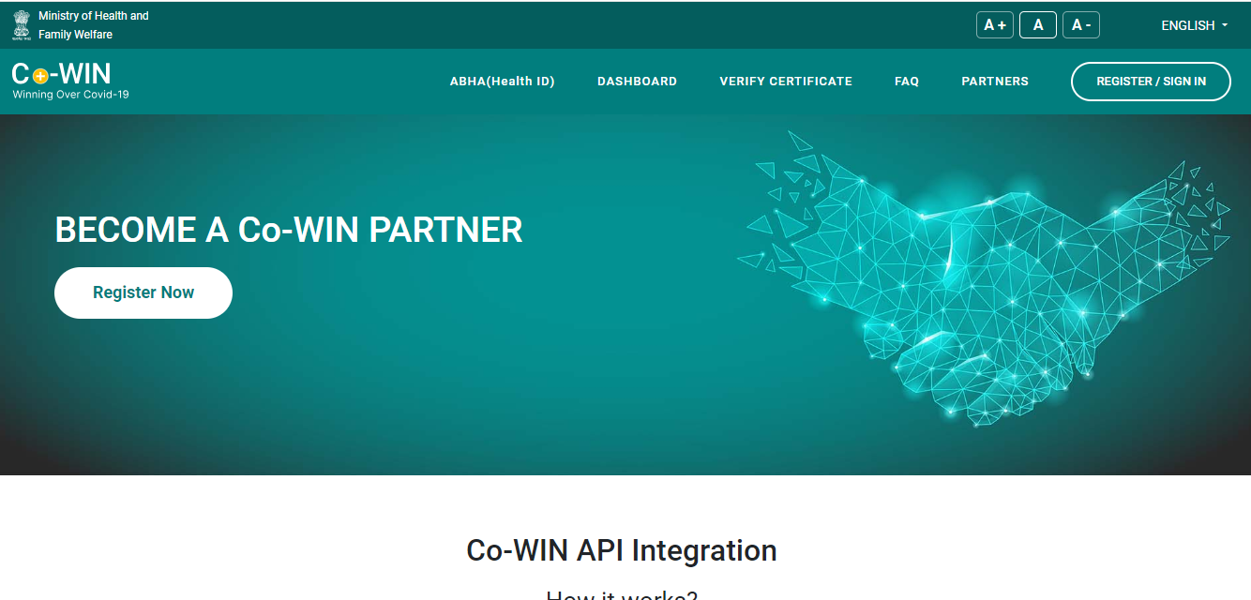

**HOME PAGE:**

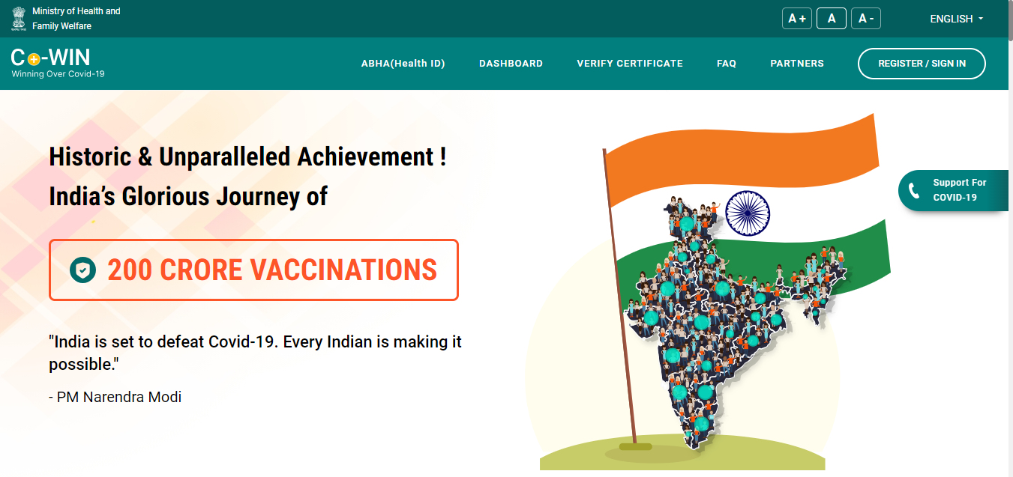

**DOCUMENTS**:

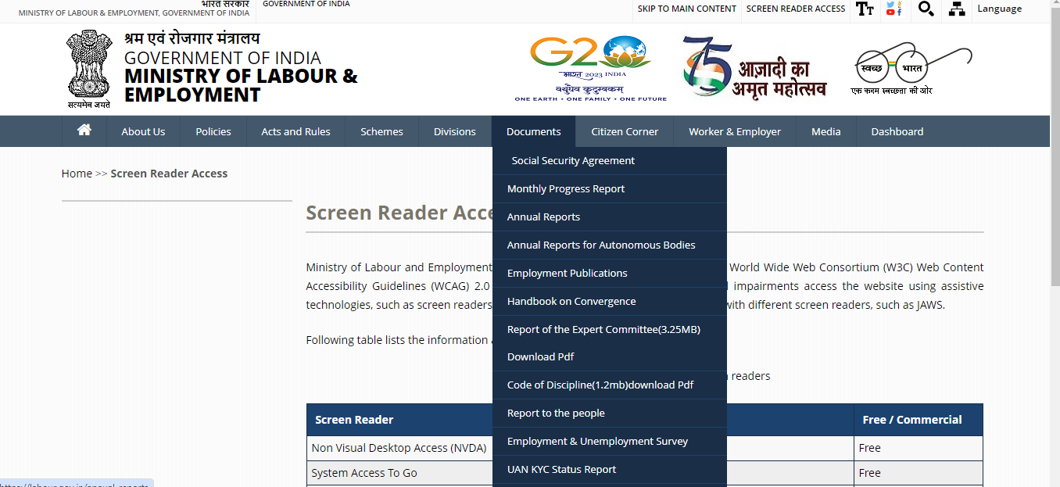

**MONTHLY PROGRESS REPORT:**

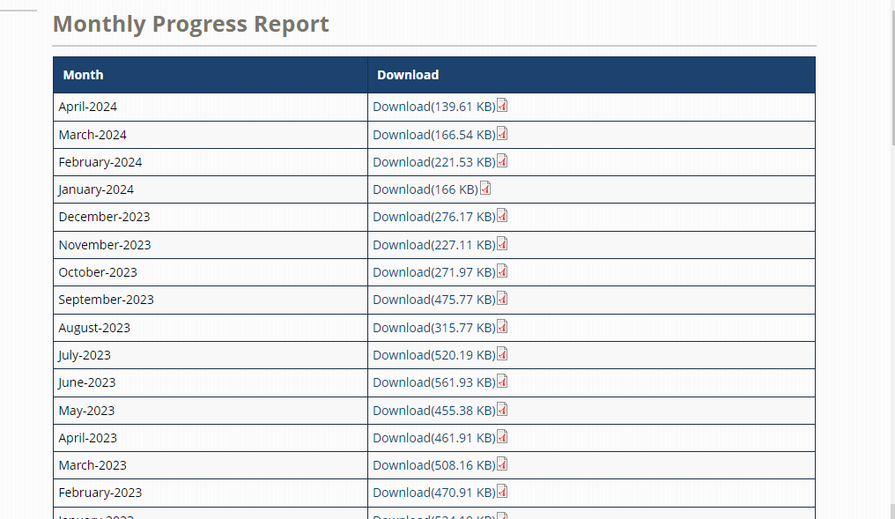

**MEDIA:**

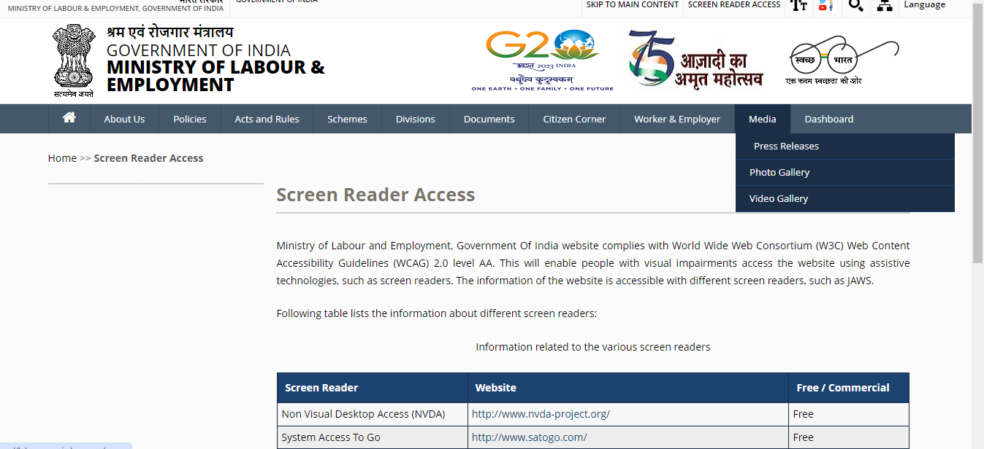

# **1.Swachhata Hi Seva**

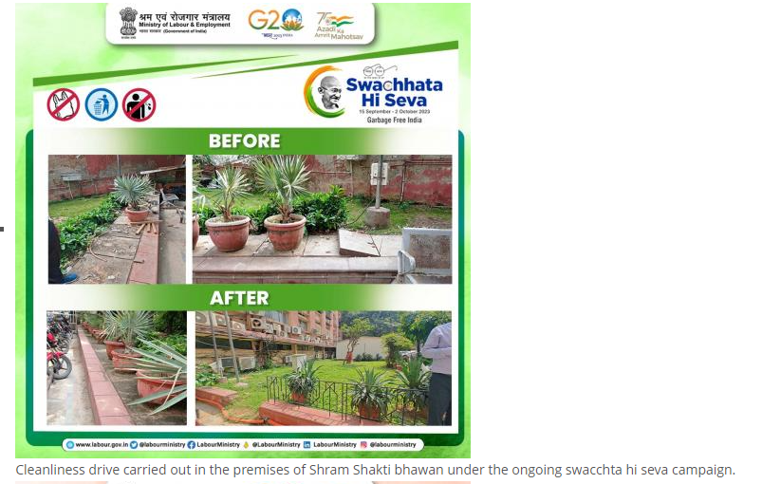

# **2. LEMM**

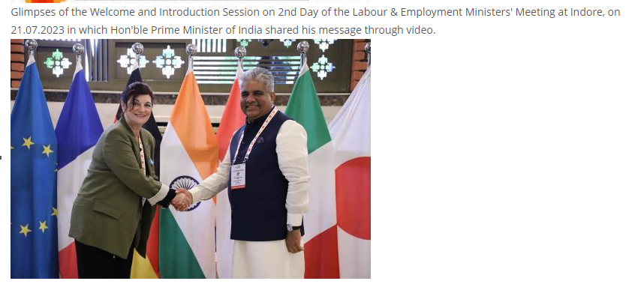

# **3. G20**

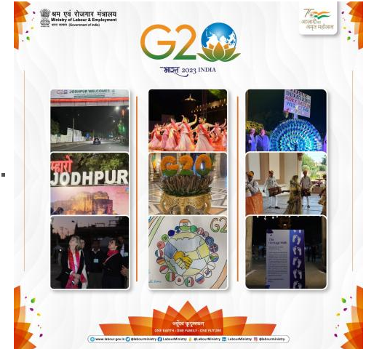

# **4. Prime Ministers Shram Awards**

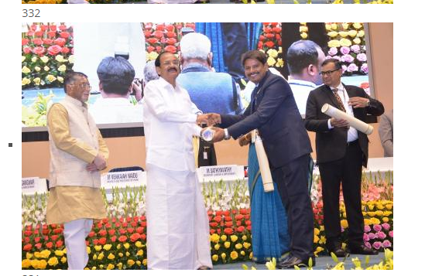

# **5. Indian Labour Conference**

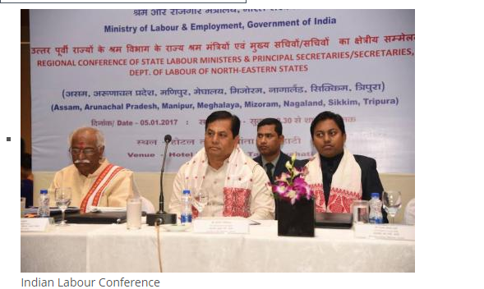

# **6. Pradhan Mantri Shram Yogi Maan-dhan(PM- SYM)**

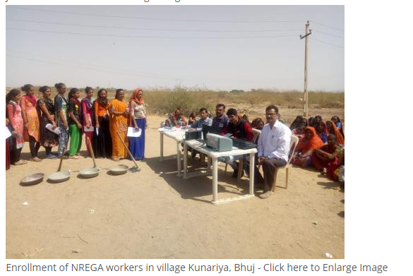

# **7. 2nd EWG**

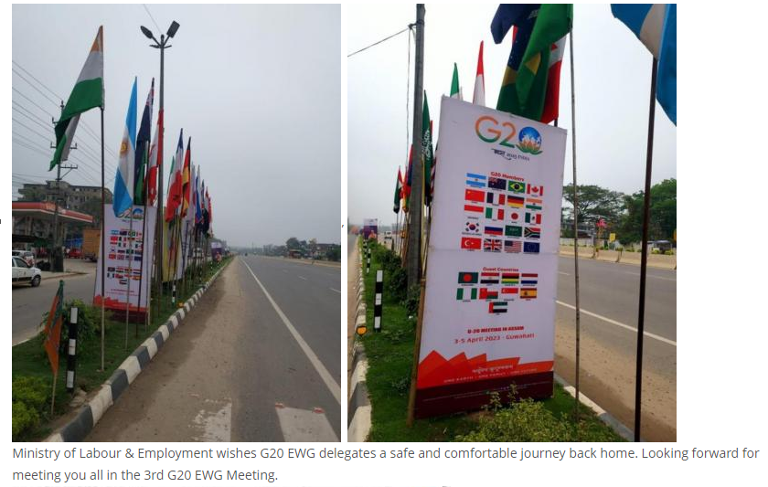

# **8. 3rd EWG**

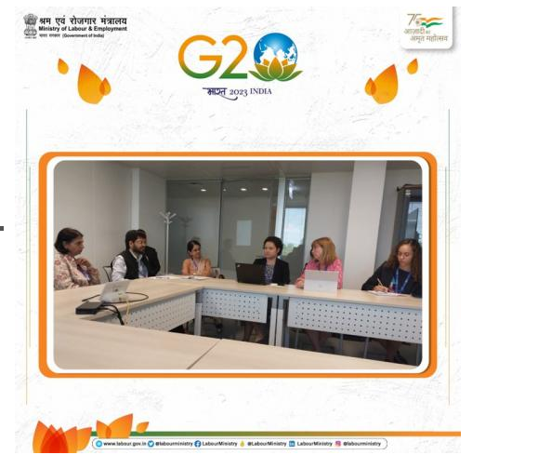

# **9. 4th EWG**

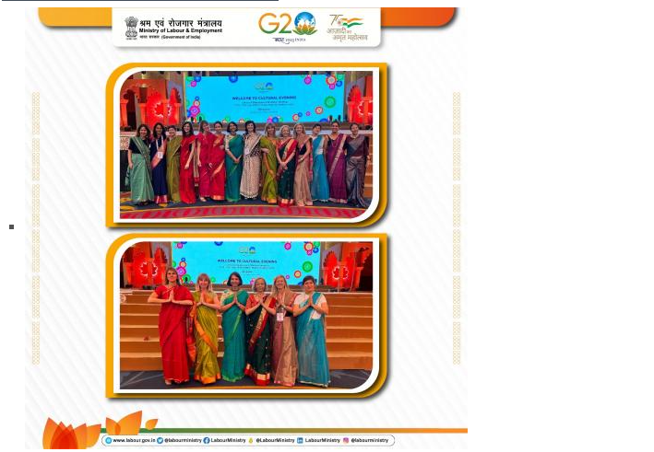

# **10. Mission Mode Recruitment**

